**Global warming and the structure of marine fish communities in the eastern Mediterranean**

D. Low Ramati1, I. Van Rijn1

1School of Zoology, Tel Aviv University, 6997801, Tel Aviv, Israel

Correspondence and requests for materials should be addressed to first author dvoralelev@gmail.com

**Abstract**

Accumulative evidence suggests warming may substantially impact natural communities, e.g., by driving seasonal changes in timing of migrations and reproduction or by causing an increase of thermophilic species and decrease of psychrophilic species. However, although the Mediterranean Sea is rapidly warming the paucity of base-line data means we do not know how species composition or the phenology of Mediterranean fishes respond to warming.

Here, we use long term and high resolution data based on fish caught along the Israeli coast between 1981 and 2018, extracted from the log books of over 16,000 fishing hauls with nearly daily reports on trawling location and catch composition.

Preliminary results suggest changes in the timing of peak catch in several species, suggesting fish arrive earlier in the spring and depart later in the fall. We also calculated the Mean Temperature of the Catch (MTC), an index, proposed by Cheung et al., 2013, that calculated form average inferred temperature preference of exploited species, weighted by their annual catch. We found both for indigenous and invasive species MTC increases through time indicating shifts in community composition towards more thermophilic species.

Those results suggest the warming Eastern Mediterranean has already impacting both species phenology and species composition. The results could help us predict future changes resulting from additional temperature increases.

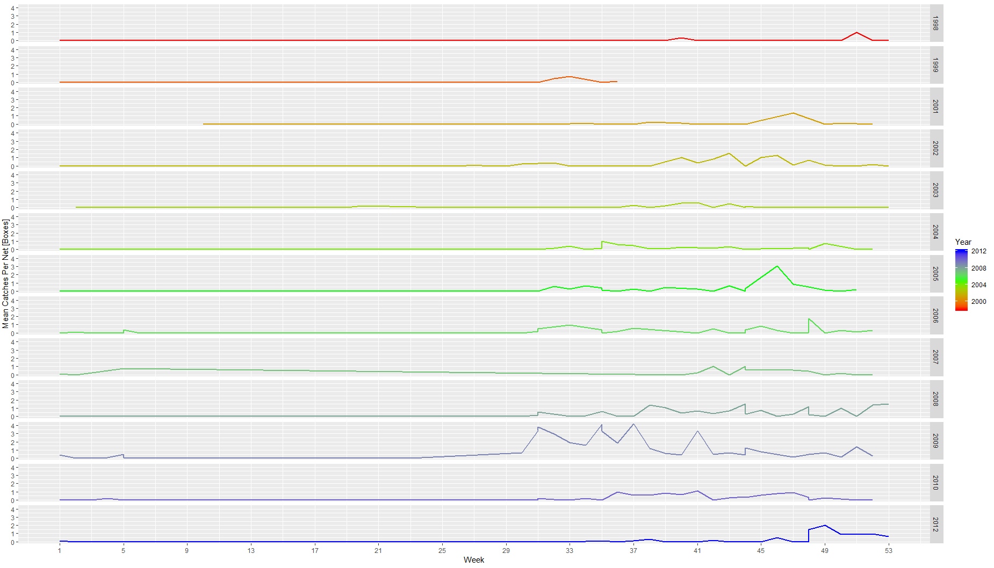

**Alteration in the peak catch time of *Scomberomorus commerson* from 1987-2013. The Y axis shows the weekly mean catch per net [in boxes] of *Scomberomorus commerson*. The X axis shows week in the year. Each line is one year. There is shift in the peak time for these species.**

**Significance**:

This study adds to the mounting evidence suggesting climate change is substantially impacting natural communities. This study also can be used to target local conservation efforts. Changes in phenology usually occur before changes in distribution or populations sizes. Hence, species with marked shifts in phenology may be those most sensitive to warming and may warrant targeted conservation efforts. Fish management often includes fishing limitations during the reproduction season. If the reproduction season is expected to change in correlation to sea warming, the fishing limitations need to be updated and modified to reflect the seasons in which species actually breed.

**Keywords:**

Phenology, Climate Change, Reproduction Season, Fish Community, MTC, Mediterranean Sea.